Introduction to Python

1. Python Installation

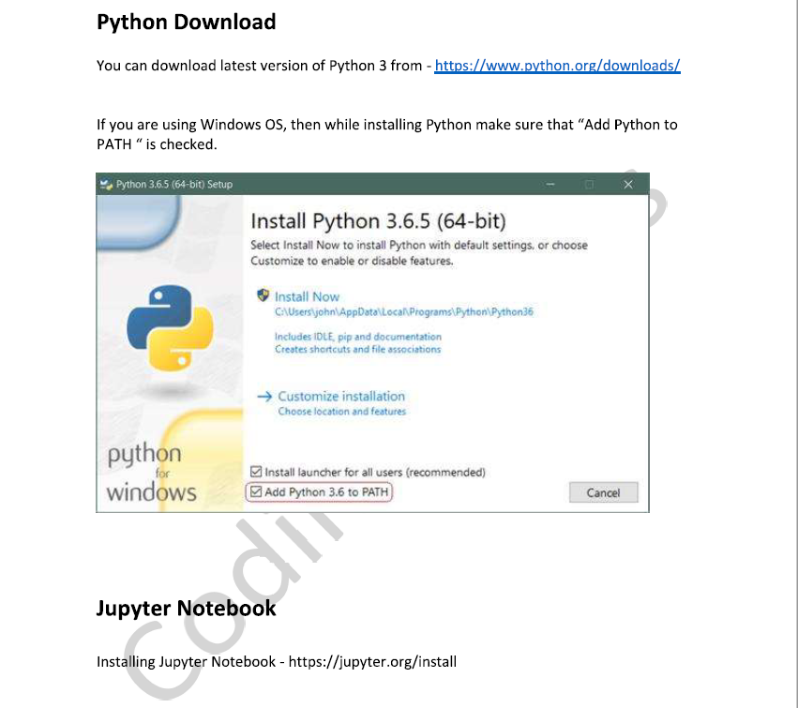

1. **Output Question**

**Send Feedback**

What will the following code segment print?

print(“Career”)

print(“Labs”)

1. CareerLabs
2. Career Labs
3. Career Labs(In Next Line) answer
4. “Career””Labs”
5. **Output Question**

**Send Feedback**

What will be the output of the given code segment?

a = 10

b = 20

multiple = a*b

print(“multiple”)

1. 20
2. 200
3. Multiple //answer
4. None of the Above
5. **Output Question**

**Send Feedback**

What will be the output of the given code segment?

a = 10

b = 20

multiple = a*b

print(multiple)

1. 20
2. 200
3. multiple //answer
4. None of the Above
5. **Python Variable Name**

**Send Feedback**

Select correct variable name(s) –

1. Var1 //answer
2. Var_1 //answer
3. 1var
4. _var1 //answer
5. **Python Vaiables**

**Send Feedback**

What will be the result of following code in Python ?

x = 10

x = "abcd"

print(x)

1. 10
2. abcd //answer
3. Error
4. **Python Variable Types**

**Send Feedback**

Consider the python code below -

x = "abcd"

x = 10

What is the type of x after the code executes ?

1. Str
2. Int //answer
3. **Check for Equality**

**Send Feedback**

Will id1 and id2 have same value?

a = 10

id1 = id(a)

b = a + 2-2

id2 = id(b)

1. Yes //answer
2. No
3. Can’t Say
4. **Output Question**

**Send Feedback**

What will be the output of following statement?

print(17//10)

1. 1.7
2. 1 //answer
3. 2
4. None of the Above
5. **Output Question**

**Send Feedback**

What will be the output of following statement?

print(17/10)

1. 1.7 //answer
2. 1
3. 2
4. None of the Above
5. **Output Question**

**Send Feedback**

What will be the output of the code if input provided is 40 and 57 ?

a = input()

b= input()

c = a+b

print(C)

1. 97
2. “40 + 57”
3. “4057” //answer
4. None of the Above
5. **Output Question**

**Send Feedback**

What will be the output of the code if input provided is 40 and 57 ?

a =int (input())

b= int (input())

C = a+b

print(C)

1. **97 //answer**
2. “40 + 57”
3. “4057”
4. None of the Above
5. **Output Question**

**Send Feedback**

### What will be the output of the code if input provided is “abc” and “def”?

a = int(input())

b=int(input())

C = a+b

print(C)

1. Abcdef
2. Abc + def
3. Value Error //answer
4. None of the Above
5. **Find average Marks**

**Send Feedback**

#### Write a program to input marks of three tests of a student (all integers). Then calculate and print the average of all test marks.

##### Input format :

3 Test marks (in different lines)

##### Output format :

Average

##### Sample Input 1 :

3

4

6

##### Sample Output 1 :

4.333333333333333

##### Sample Input 2 :

5

10

5

##### Sample Output 2 :

6.666666666666667

Assignment

1. **Find X raised to power N**

**Send Feedback**

#### You are given two integers: X and N. You have to calculate X raised to power N and print it.

##### Input format:

The first line of input contains an integer X (1 <= X <= 100)

The second line of input contains an integer N (1 <= N <= 10)

##### Constraints:

Time Limit: 1 second

##### Output format:

The first and only line of output contains the result.

##### Sample Input:

10

4

##### Sample Output:

10000

1. **Arithmetic Progression**

**Send Feedback**

#### You are given first three entries of an arithmetic progression. You have to calculate the common difference and print it.

##### Input format:

The first line of input contains an integer a (1 <= a <= 100)

The second line of input contains an integer b (1 <= b <= 100)

The third line of input contains an integer c (1 <= c <= 100)

##### Constraints:

Time Limit: 1 second

##### Output format:

The first and only line of output contains the result.

##### Sample Input:

1

3

5

##### Sample Output:

2

1. **Rectangular Area**

**Send Feedback**

#### You are given a rectangle in a plane. The corner coordinates of this rectangle is provided to you. You have to print the amount of area of the plane covered by this rectangles.

#### The end coordinates are provided as four integral values: x1, y1, x2, y2. It is given that x1 < x2 and y1 < y2.

##### Input format:

The first line of input contains an integer x1 (1 <= x1 <= 10)

The second line of input contains an integer y1 (1 <= y1 <= 10)

The third line of input contains an integer x2 (1 <= x2 <= 10)

The fourth line of input contains an integer y2 (1 <= y2 <= 10)

##### Constraints:

Time Limit: 1 second

##### Output format:

The first and only line of output contains the result.

##### Sample Input:

1

1

3

3

##### Sample Output:

4